Anger Cycle
Below is an outline of the anger cycle. It’s easy to get trapped in an endless loop of repetitive anger-fueled outbursts. Fortunately, the cycle can be broken at several points, although the earlier you start, the easier it is to snap out of it.
The body releases adrenaline and corticosteroids as you become angry. These are the chemicals that underlie the classic “fight or flight” response when you perceive danger. It’s entirely possible to become addicted to the “rush” of these chemical releases and find yourself becoming angry more and more frequently.
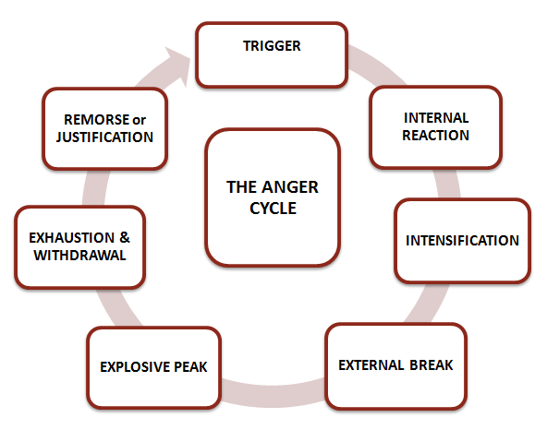

1. Trigger (“Hot buttons” such as words, subjects, perceived threats, criticism, loss, frustration)
2. Internal Angry Reaction (“Hey, something doesn’t feel right here.”)
3. Internal Intensification (Justification, often based on false assumptions, onset of chemical release, breathing and heart rate speed up)
4. External Barrier Break (Shouting, screaming, crying, accelerated chemical release, red face, fist pumping, foot stomping, gesturing)
5. Explosive Peak (Could be physical violence, hitting, kicking or slamming)
6. Exhaustion and Withdrawal
7. Remorse and Apology — or – Intense Justification
8. Repeat
Breaking the anger cycle begins with developing awareness of your personal triggers and identifying opportunities to change your reactions. The earlier in the cycle you start trying to respond differently, the greater your chances for success.
Anger Quiz
1. Has your anger ever caused you to hurt anyone (including yourself)?
a. No, never
b. Once or twice
c. A few times
d. Yes, many times
2. Have angry outbursts damaged your marriage, friendships or other relationships?
a. No, never
b. Once or twice
c. A few times
d. Yes, many times
3. Has your temper ever caused you to lose a job?
a. No, never
b. Only once
c. Twice
d. Yes, several times
4. Has your anger caused domestic violence, fighting or an arrest?
a. No, never
b. Once
c. Twice
d. Yes, several times
5. Have you ever felt remorse, shame or despair after an angry episode?
a. No, never
b. Once
c. Twice
d. Yes, several times
6. Have friends or family members commented that your anger seems excessive?
a. No, never
b. Once or twice
c. A few times
d. Yes, several times
7. How strong is your desire to learn to control your anger?
a. I am in total control of my anger
b. I know I need to work on it, but I’m not ready now
c. My interest in controlling my anger is growing
d. I really need to learn how to manage my anger
8. Has anyone indicated they are afraid to be around you when you are angry?
a. No, never
b. Once
c. Two or three times
d. Yes, many times
9. When you are angry do you seek relief by overindulging in food, alcohol, prescription drugs or engaging in other self-destructive or excessive behaviors?
a. Never
b. Once or twice a year
c. Several times a year
d. Often
10. How would you describe your anger level in general?
a. I am not an angry person
b. I rarely get angry
c. I get fired up on occasion
d. I know my temper is causing big problems
Scoring: A=1, B=2, C=3, D=4
Results 10 – 16: Within Normal limits
17 – 25: Low Risk
26 – 33: Moderate Risk
34 – 40 – High Risk

Stop Anger
Here are some more anger control tips and techniques that can help you stop angry outbursts.
Analyze Your Self-Talk
Take a moment to reflect on your inner dialogue. What tone of voice do you use with yourself?
Many angry people are pretty rough on themselves. See if you can develop the habit of speaking as kindly to yourself as you would to a dear, close friend. Use encouraging terms and a gentle tone of voice.
It may take time to develop this habit, but you’ll be amazed at how the way you speak to yourself spills over into how you speak to others.
Avoid Getting Too Hungry, Tired or Lonely
Changing your behavior is no small challenge. It takes commitment, patience and persistence. People are most vulnerable to anger and returning to old behavior patterns when they become overly hungry, tired or lonely.
So increase your chances of successfully controlling your anger by taking care of your physical self. Keep your blood sugar steady by eating healthy foods at regular intervals, get some regular exercise, and take time to relax with your family and friends.
The 1-2-3 Punch: Stop-Breathe-Squeeze
This is the tip that can break the anger cycle. As soon as you feel yourself getting upset, instigate the stop-breathe-squeeze sequence:
- Stop talking immediately (do not allow yourself to say another word, no matter how justified you feel you are)
- Starting taking deep, controlled breaths (inhale through the nose, hold for 2-3 seconds, exhale slowly through the mouth)
- Grab onto something you can’t hurt (a steering wheel, a door handle or just clasp your hands). The point here is simply cause a break in your reaction so you have a chance to regain control.
Indulge in Healthy Rewards
A lot of people are prone to anger because their needs are not being met. Taking care of yourself physically, emotionally and spiritually can go a long way in neutralizing excessive anger.
Be kind to yourself and make sure to give yourself credit for having the courage to do something about controlling your anger. Give yourself healthy rewards. How about a massage, a week-end getaway, a movie, a hot bath or a long, leisurely walk where you actually stop to smell the roses?

